Key vocabulary
gravity | A force which pulls things down towards the centre of the Earth.
gravitational pull | The force that pulls objects toward the Earth (or toward each other), making things fall down.
forcemeter | Piece of equipment used to measure the size of a force.
Newton (N) | The unit for measuring force.
air resistance | The force that slows down objects that move through air.
water resistance | A force that slows down objects moving through water.
friction | When one surface moves against another, the rubbing force that tries to stop them is called friction. It gives us grip.
upthrust | A push upwards from water or air that helps an object to float.
mechanisms | A device that allows a small force to be increased to a larger force.
simple machines | Levers, pulleys and gears are all types of simple machines.
Real-life examples of forces in action

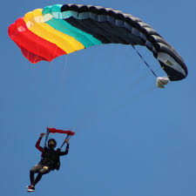  A skydiver falls fast until they open their parachute. |  | 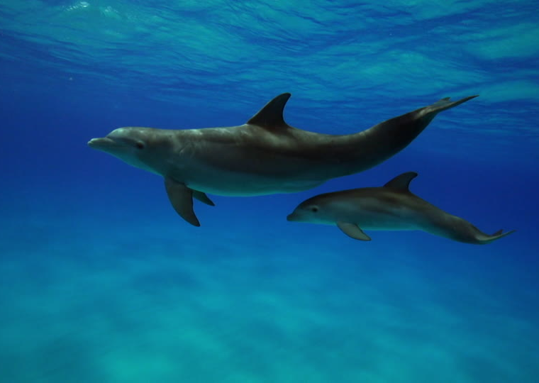  Dolphins have a streamlined shape.
Key scientist
Sir Isaac Newton  (1642-1726)  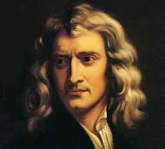 |  |  | He was an English scientist and mathematician.  He ‘discovered’ the concept of gravity when sitting under a tree and an apple fell to the ground near him.
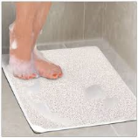
A non-slip mat uses friction.


Seeds fall to the ground because of gravity.

Simple machines
These are used to make tasks easier. This means you need to use less force.
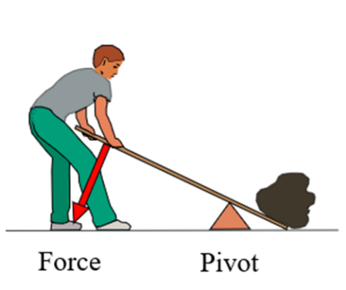
A lever tilts on a pivot which is nearer to the end of the pivot with a heavy load.
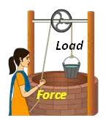 | 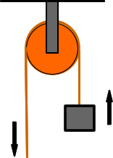
Pulleys have a rope or cable which goes over a wheel. This is pulled to lift, lower or move heavy objects.
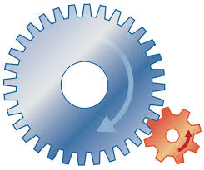
Gears are toothed wheels which lock together and turn each other to form simple machines.

