Key vocabulary
insects | A small invertebrate animal. It has a body divided into three main parts (head, thorax, abdomen), three pairs of jointed legs, a pair of antennae, and usually one or two pairs of wings. Insects have an exoskeleton.
algae | Simple living things that grow in water or very damp places. They are not plants, but they make their own food using sunlight.
moss | Moss is a tiny green plant that usually grows in damp, shady places. It doesn’t have flowers, seeds, or roots like most plants.
vertebrate | A vertebrate is an animal that has a backbone (spine) inside its body.
invertebrate | An invertebrate is an animal that does NOT have a backbone.
dichotomous Key | A dichotomous key is a tool that helps you identify things, like plants or animals, by answering a series of questions. Each question has two choices. You pick the answer that fits, and it leads you to the next question until you find the name of the thing.
organism | A living thing. E.g. plant, animal, single celled life form.
taxonomy | The branch of science concerned with classifying organisms into groups.
botanist | An expert in the scientific study of plants.
Significant scientist
Carl Linnaeus  (1707-1778)  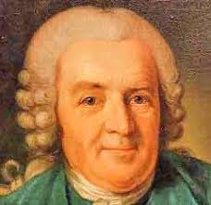 | Carl Linnaeus was a Swedish scientist who developed the modern system of classifying and naming organisms. Before this the names of living things were often very long. He gave them a two-part name.
Classification
Living things can be classified into broad groups according to observable characteristics that are similar or different.

Micro-organisms
These are tiny living creatures. Most can only be seen through a microscope. They can be sub-divided into smaller groups including bacteria, fungi and viruses.

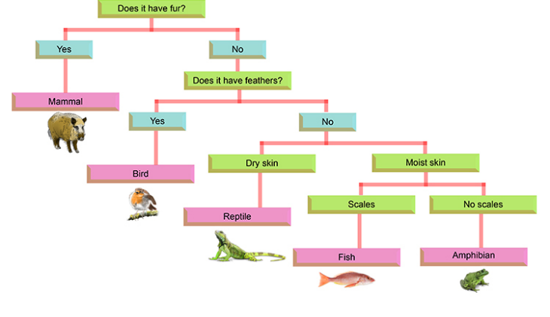
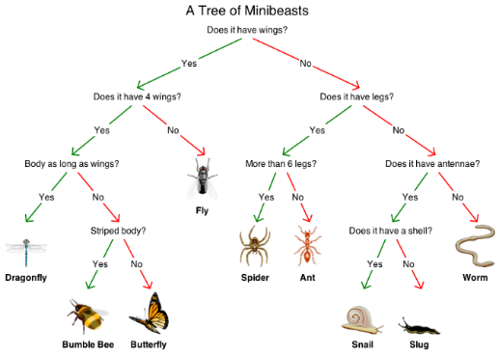
Classifying vertebrates
Classifying invertebrates
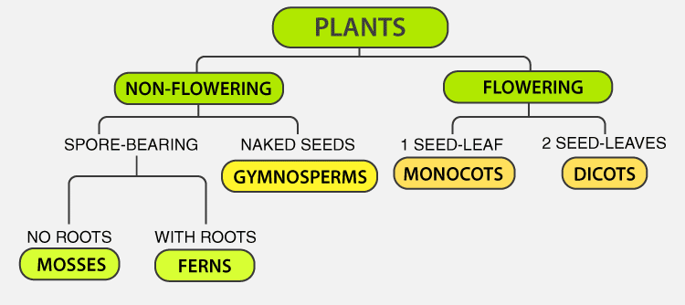
Flowering plants – numerous and diverse group. Reproduce through flowers and seeds. E.g. sunflower
Non-flowering plants – smaller group. They have a simple structure and do not have flowers or seeds. They reproduce through spores. E.g. algae, mosses

