Key Places and Dates | Key People
Warrington-Dallam  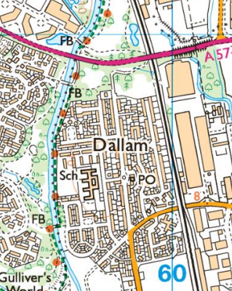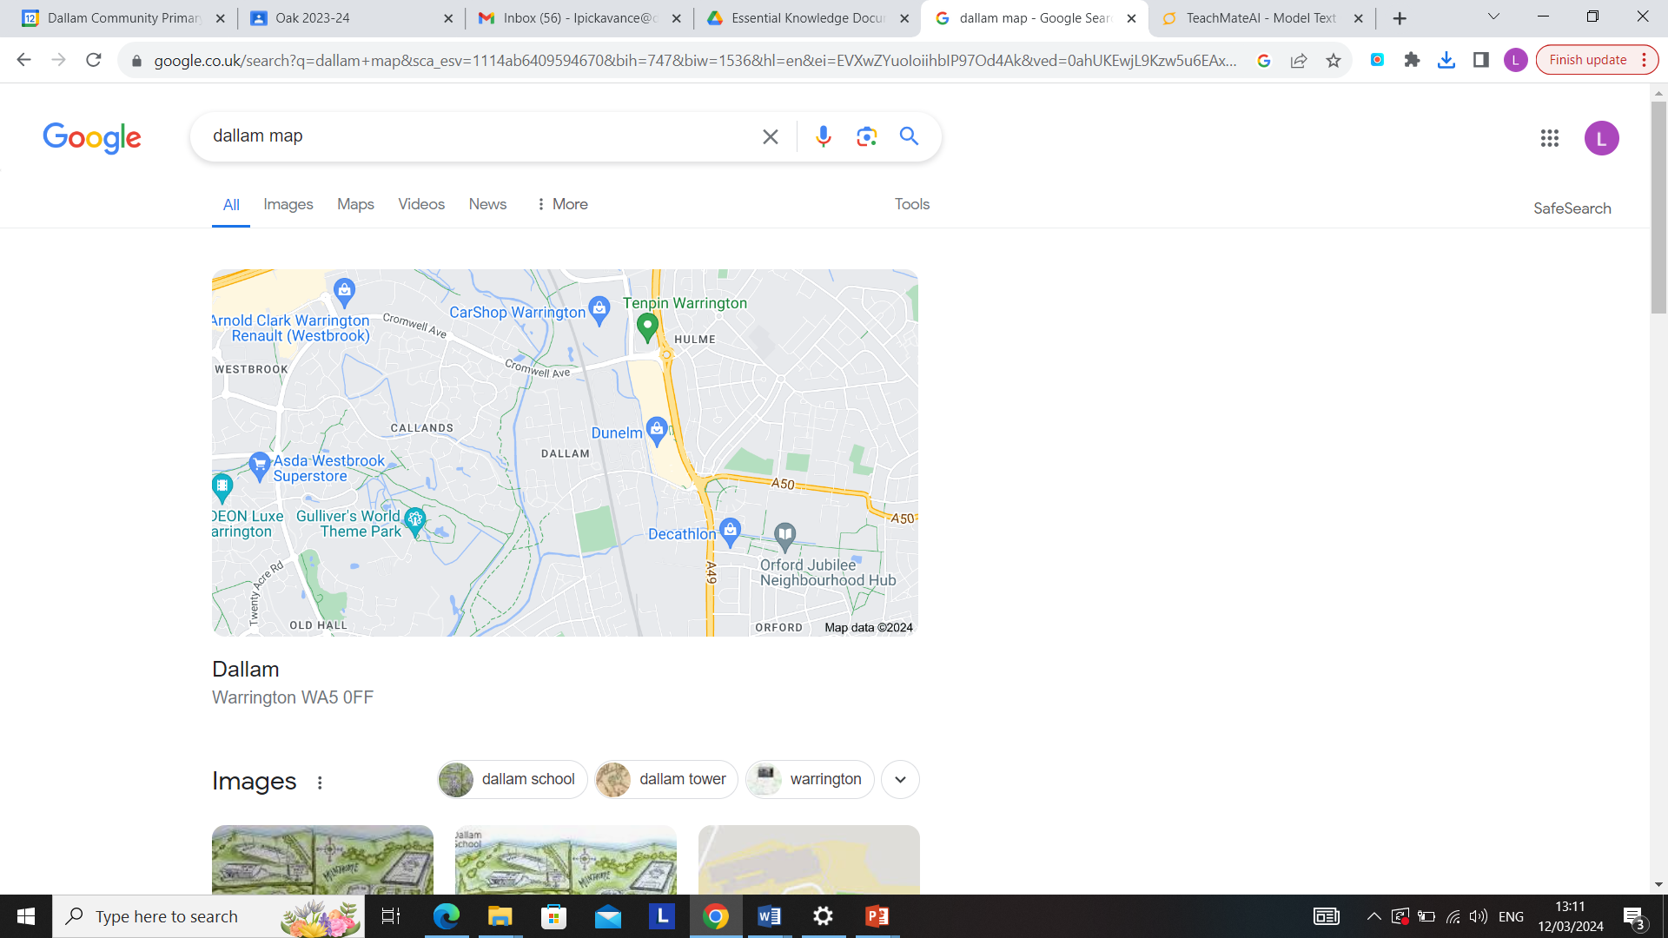 | Sarah Hall MP-the Member of Parliament for Warrington South.  
Key Facts | Vocabulary
● There are many different ways to present the findings of fieldwork enquiries including: videos, web pages, brochures, models and reports.  ● OS maps show physical and human features as symbols.  ● A compass can be made more accurate by adding 4 more points to the four cardinal points.  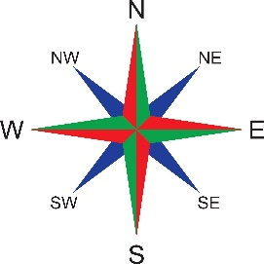
  Campaign | a series of planned actions carried out in order to reach a particular goal.
  Environment | the surroundings or conditions that a living organism (people, animals, plants) finds  themselves in
  Ordnance Survey Map | a detailed map showing  the human and physical features as symbols.
  Grid reference | a description of a location using  vertical and horizontal grid lines, indicated by  numbers and/or letters.

