Key Places | Key People
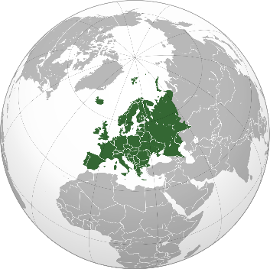  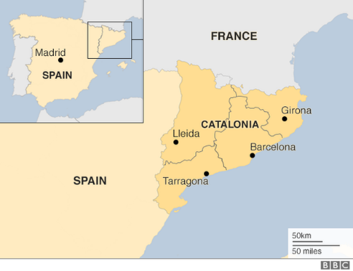  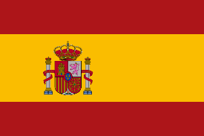  Catalonia, Spain  Europe | Muhammed Al-Idrisi  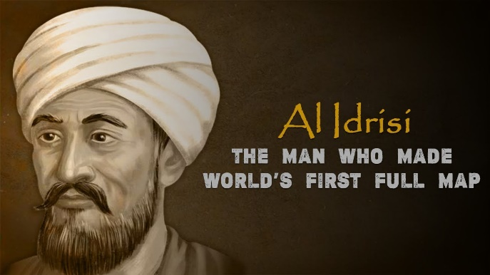  1100 - 1165  A Muslim cartographer who focussed mainly on Europe and Africa.
Key Facts | Vocabulary
- 46 countries make up the continent of Europe.  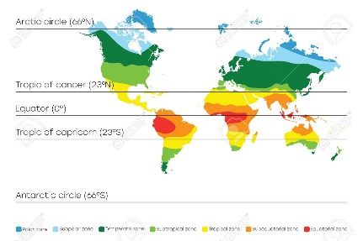  - Europe is generally described as having a temperate climate but also has Mediterranean and Polar.  - The Arctic and Antarctic Circles are special lines of latitude that circle the Earth.  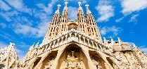  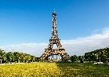  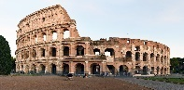  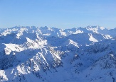  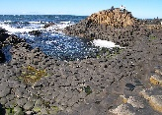  - Key human features in Europe include the Sagrada Familia, the Eiffel Tower and the Colosseum.  - Key physical features in Europe include the Pyrenees Mountain Range and Giant’s Causeway. | climate average daily and seasonal weather patterns  climate zones an area that has its own distinct climate  longitude vertical, imaginary lines running from the North Pole to the South Pole  latitude horizontal, imaginary lines, above and below the equator

