DALLAM PRIMARY SCHOOL
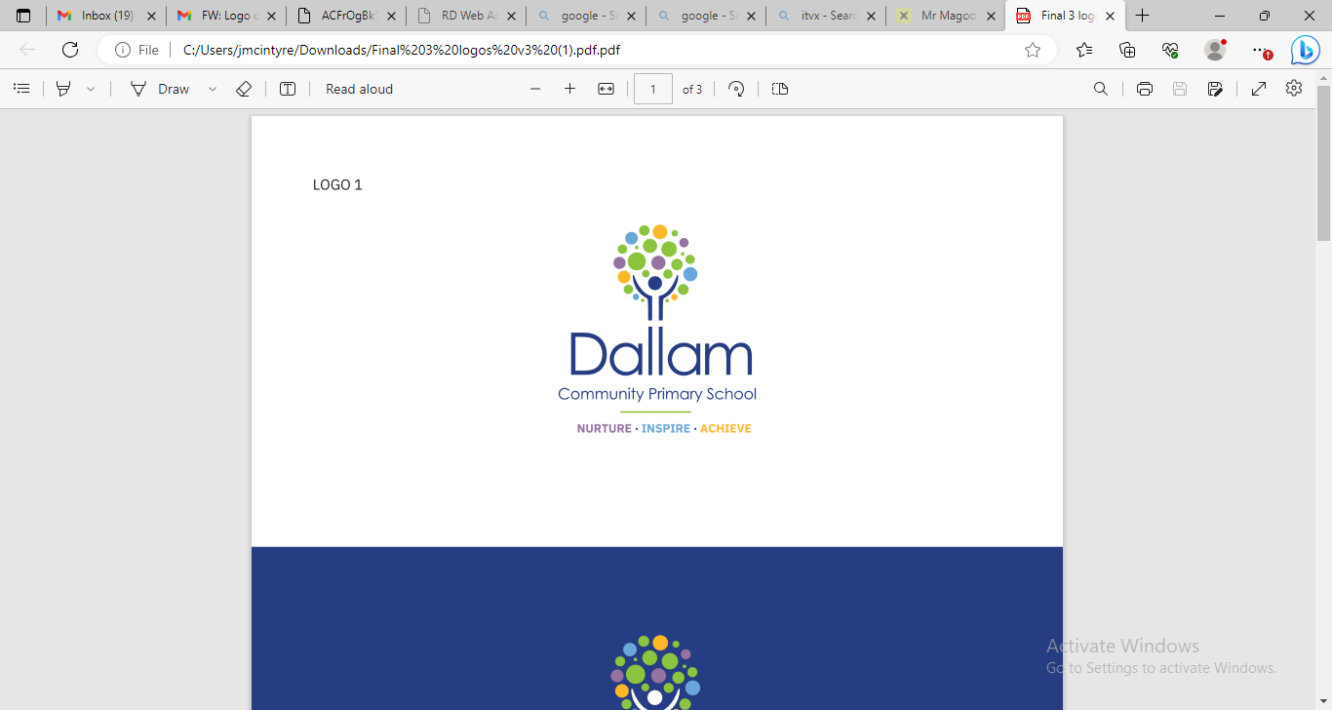

MUSIC POLICY

Date of this Review | April 2025
Next Review due | May 2026

Staff Author: L Wigley
Intent
Music is a powerful force for creativity and expression. It can stimulate the imagination, enable reflection and promote emotional development. At Dallam, pupils of all abilities will be given the opportunity to develop listening, appraising, composition and performance skills, to gain an understanding of musical elements, structure and history and to realise creativity by participating in a broad and engaging range of musical activities in school.
At Dallam Primary School we use the Statutory Framework for the Early Years Foundation Stage (2017) and the National Curriculum for England (2014) and elements of the Model Music Curriculum (2021) to:
- Foster a love of music; listening, composing and performing to develop and deepen skills in these areas
- Expose the children to a broad range of music from different genres, countries, instruments, voices, time periods including live performances
- Teach children to form their own opinions, whilst learning to appreciate and critique pieces of music developing questioning and enquiry skills.
- Enable the children to understand how music can help regulate emotions and create moments of happiness and relaxation in everyday life, improving well-being and increasing self-esteem and confidence.
- Promote the understanding of intentions and emotions behind music and why music has developed in certain ways
- Teach a broad knowledge base of instruments, genres, performers and composers enabling the pupils to become confident using music vocabulary to talk about these
- Promote collaborative working to produce music and to appraise each other’s work.
- Ensure the children understand how the universal language of music can make a positive difference in our school, the wider community and the world.

Implementation
Planning and resources: At Dallam we use Kapow as a basis for planning music, which is an engaging and well-structured scheme, supporting development both within each year and from one year to the next. Progression centres around the four key strands (listening, composing, performing and the history of music) alongside the interrelated dimensions of music, promoting development of key concepts and musical vocabulary: pulse, pitch, duration dynamics, tempo, timbre, texture, structure and musical notation.
By using Kapow as the basis of a scheme of work, we can ensure that children are fulfilling the aims for musical learning stated in the National Curriculum. Through a range of whole class, group and individual activities, children have opportunities to explore sounds, listen and appraise actively, compose, perform and develop notation skills. Our curriculum enables children with SEND to be fully included in all lessons and is accessible to Designated Provision classes.
We use the Kapow condensed long term plan which allows for development of key areas that we know we need to prioritise, deepen, embed and extend for our children. Teachers develop and expand Kapow planning further for their own class depending upon the particular needs and interests of the cohort. As much as possible, cross-curricular links are made with other areas of current learning. The Kapow condensed plan, while covering all elements of the curriculum, also allows for flexibility to embrace additional units or activities to enhance musical learning, such as the Samba drumming unit in Year 4 or the Magic Flute opera unit in Year 2.

EYFS | Music takes place on a daily basis as part of phonics and number work.  Children begin to listen and respond, explore, sing, play, create, share and perform. Initial use of vocabulary is taught to support learning and further opportunities for learning are integrated into Continuous Provision.
KS1 | Children develop listening and appraisal skills, describing and sharing their opinions on music. They compose more formally and start to learn graphic notation. Vocabulary is further developed and they begin to learn the inter-related dimensions of music, applying these to what they hear and create.
KS2 | Children significantly develop skills of evaluation, appraisal and opinion of music as they recognise, describe and discuss stylistic features. They deepen their composition skills and develop their notation skills, representing changes in music and justifying their decisions. They develop more complex lyric and melody writing and perform with more accuracy and fluency. The children can use technical music vocabulary in their discussions.

In order to offer true breadth of musical learning at Dallam and to make sure our children have quality experiences, we ensure that the following activities take place each year:

- Specialist teaching of Samba drumming for year 4 culminating in a summer performance
- Annual orchestra visits to school offering workshops for all children
- Whole school singing assemblies where a new song with a theme, message or link to our school values is taught every half term
- Morning music played every day over the tannoy system showcasing a variety of genres, providing listening, appraising and familiarisation with a range of styles
- Active and popular Key stage 2 choir who perform every term to the school and/or community and take part in a large celebratory performance alongside other schools twice a year at the Parr Hall.
- High Quality CPD for music leaders and teachers offering support for key stages and SEN learners
- Development of cultural experiences across school including opera workshops and units of work
- Regular live workshops and concert visits for all classes throughout the year offering a range of activities at different venues (eg visit by local youth orchestra, class trip to a Liverpool Philharmonic concert, live remote opera workshops)
- Christmas performances with narration and song
- Children within Designated Provision classes take part fully in the above activities alongside their peers.
- An end of Year 6 performance involving singing, speaking and acting
Resources: We have a wide range of tuned and untuned percussion instruments as well as a selection of other tuned instruments such as glockenspiels. Classes all have access to ipads for the use of music apps to support learning.
Impact
At Dallam we examine data gathered by teachers at the end of each term, against the learning objectives. However the impact of music reaches beyond measurable objectives and impacts on confidence, self-esteem and an ability to appreciate and engage with music. We aim to observe this impact as well and gather that in photos, videos, recordings, floorbooks and anecdotal evidence.
We measure the impact of music by
- Assessment of music expectations, gathered and reported in report to governors
- Music evidence of progress is recorded in videos every term and shared with music co-ordinator
- Pupil interviews reflect on the children’s experiences and development throughout the year
- Informal feedback gathered from children and parents at events
- Observing music lessons
- Discussions with teachers and coaching where necessary
- Monitoring of planning and evidence gathered in floorbooks and other audio and video recordings.

