Key Vocabulary | Key Dates | Key Places
Empire a group of countries ruled by a single person, government or country  Industry The process of making goods using machines and factories  Revolution a huge change in the way something is done  Rural countryside  Urban town or city  Urbanisation the growth of cities due to movement of people  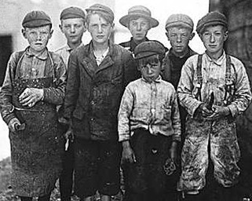 | - 1750-1900 – the period called The Industrial Revolution.  - June 1837 – Queen Victoria became queen.  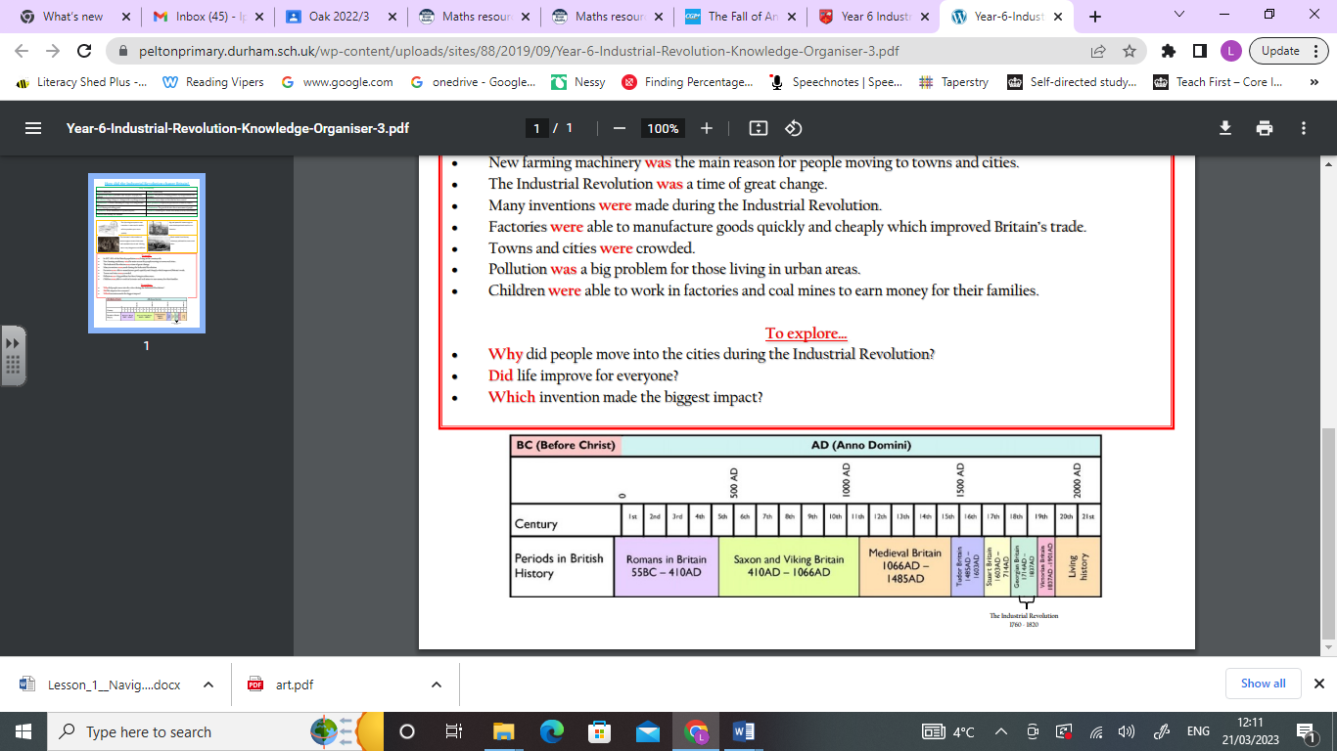 | 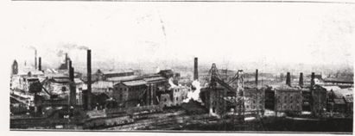  Joseph Crosfield’s Soap Factory,  Bank Quay, Warrington  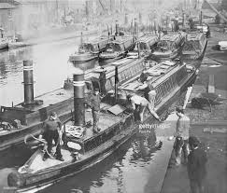  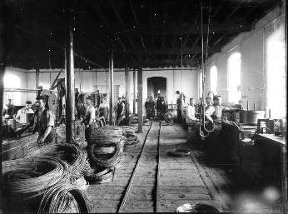  Q  Carrington Wire Works,  Battersby Lane, Warrington  The Manchester  Ship Canal  Ben Nevis
 | Key People | Key Facts
 | James Hargreaves 1720 – 22 April 1778 James was an English weaver, carpenter and inventor who lived and worked in Lancashire, England. He was one of three men responsible for the mechanisation of spinning: Hargreaves is credited with inventing the spinning jenny in 1764 | - The Industrial Revolution saw great change in the way products were made.  - New inventions included the steam engine, the telephone and The Spinning Jenny.  - Warrington became a manufacturing town and a centre of wire, soap, copper and pin industries.

