Key Vocabulary | Key Dates
architecture The process of designing buildings with a focus on the style.  democracy A form of government in which power rests with the people.  engineering Using maths and science to do practical things.  Mount Olympus The highest mountain in Ancient Greece and home to the Greek gods.  Zeus God of the sky and father of the gods in Greek mythology. | - 800BC- The Greek civilization slowly began to emerge.  - 776 BC - The first Olympic Games takes place.  - 600AD- End of the Greek era.  800BC  The Greek civilisation slowly emerges.  440’s BC  Greek theatre thrives; many of the most famous Greek plays are written  Hippocrates  C 470 – 400 BC  Known as the Father of medicine, he believed that illness was due to natural causes, not the gods.  776BC  The first Olympic Games take place  450BC  Athens becomes a very powerful city and controls an empire. | 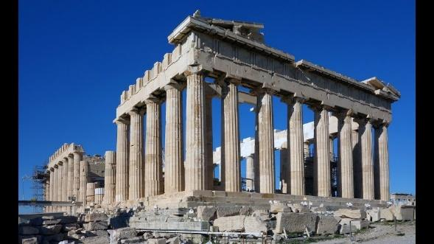  146BC  The Romans conquer Greece.  0AD  The birth of Jesus Christ.
 | Key Places Key People | Key Facts
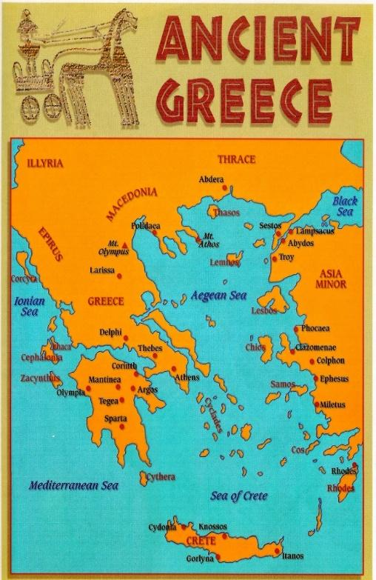
- The Ancient Greeks lived about 3,OOO years ago.

- Ancient Greece was not a single country but was made up of many city states. The most famous are: Athens, Sparta and Corinth.

- One of the favourite forms of entertainment was the theatre.

- The ancient Greeks were fierce competitors; they invented the Olympic Games.

